Practicum Case | 
COMP7116 | COMP7116001 | COMP7116016 | MATH6168 | MATH6168016
Computer Vision
Computer Science | O221-COMP7116-WB01-01
Valid on Odd Semester 2024/2025 | Revision 00

Learning Outcome
- LO 3 – Employ various features to find the correspondence between images and perform recognition in computer vision
- LO 4 – Build various image recognition system in computer vision

Topic
- Session 9 – Image Retrieval

Sub Topics
- Similarity Index
- Result of Representation

Soal
Case
WBlues Music Shop
You are an really good friend to Wilbert, so you also know his favourite song genre. His favourite is Rhythm and Blues or RnB. In less than 24 hours, Wilbert will celebrate his 21th birthday. You as a good friend of Wilbert want to give his favourite RnB Album which is Tom Misch album, that named Geography. Unfortunately, you didn’t have enough time to seek all of your album list to get that one specific Tom’s albums. But as a professional programmer, you already learned about Image Retrieval using Euclidean Distance from Scipy Library at university. So, you want to create a program that can find specific Tom’s album on your own album list, so you didn’t have to check it manually one by one.
- Image Retrieval using Euclidean Distance
- Make a program to find the desired album on your Album List. Make sure to use the assets given on this case.
- Additional: You can also set title results, to showing the filename of the matched album to make you easier located the album and its distance to showing the accuracy of the results.
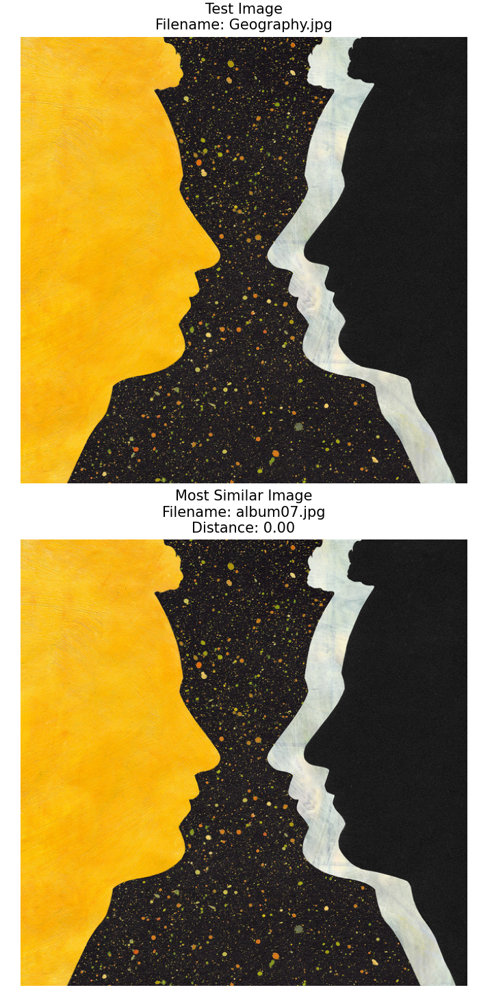
Figure 1. Example of matching Album

